Assignment Day 8

Assignment 0

1. Create a simple shell script to tell the user about their session – they need to know:

● what their username is ● what the current date is ● What the time is ● What their current working directory is ● How many files they have in that directory ● What is the biggest file in their current directory.

*Shell Script*

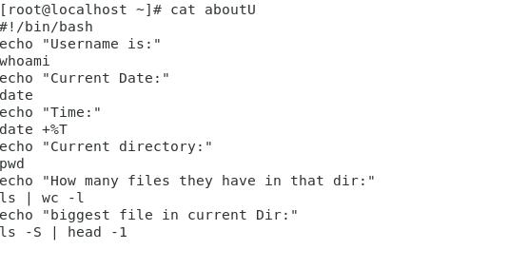

*Output*

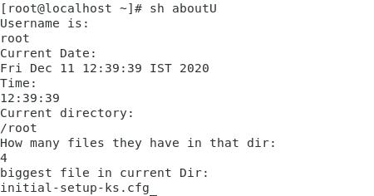

Assignment 1

Create a directory with a few test files in it (the files can be empty). Now write a script that for every file in that directory you rename it to have an extension of today's date in YYYYMMDD format.

**#!/bin/ksh**

**SCRIPT=$(basename ${0})**

**LOG="${SCRIPT}_`date +%m%d%y%H%M%S`**

Assignment 2

Write a script that takes a number as an input and reverses it out to the user. For example, if the original number is 74985, the output should be 58947.

*Shell Script*

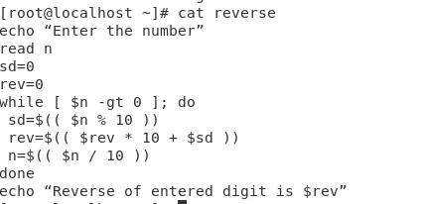

*Output*

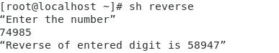

Assignment 3

Write a script to validate how secure someone's password is. Things you would care about:

● Length should be 8 or more characters

● The password should contain numbers and letters

● There should be both uppercase and lowercase letters

